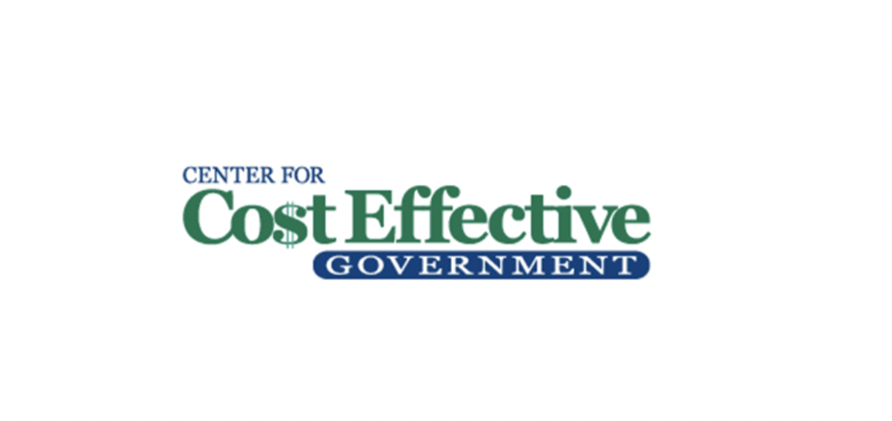
November 2022

THE HIGH COST OF PUBLIC SECTOR RETIREE BENEFITS IN NEW YORK

A simple, doable reform, such as a tweaking of the healthcare packages for retired teachers and other public retirees in New York, can save the region’s taxpayers hundreds of millions of dollars each year, while still providing needed care for retirees.

While most private sector employees shift over from their work-related insurance to Medicare when they hit the age of 65, most retired teachers on Long Island, as well as many other public sector employees on the Island and throughout the state, get to keep additional healthcare coverage - paid in large part by the taxpayer.

And while most residents throughout the nation pay for supplemental Medicare Part B out of their own pockets, the overwhelming majority of retired teachers (as well many other public employees) receive checks from the taxpayers in their district to provide 100% reimbursements for what the retirees shell out for this program.

Our analysis, which builds off a prior study from the Empire Center, a New York based think tank, estimates that taken together, these perks for Part B alone add a whopping half a billion dollars in extra costs to New York taxpayers each year. The entire price tag to cover all healthcare benefits amounts to an astonishing $360 billion.
https://www.empirecenter.org/publications/nearly-360-billion-in-debt/

Paying school district retirees on par with the average private sector counterpart, as it pertains to Medicare, would provide enormous relief for taxpayers without having the slightest impact on the quality of education for our children.

Property taxes on Long Island are amongst the highest in the nation. Nassau and Suffolk counties on Long Island are ranked at or near the top of the list of the ten highest property tax burdens in the nation.

School district taxes account for approximately 2/3 of the property tax burden on Long Island.

The lion’s share of district costs relates to personnel. That includes not only salaries that average above $100,000 in most districts but also enormous perks, including Cadillac-type healthcare packages for present and retired employees. Nearly 31,000 educators on Long Island earn six figures.

Equally significant to these lofty salaries is the fact that the fringe benefits can amount to 50% of the actual salary itself. Thus, for every $100,000 paid to an average teacher, another $50,000 must be allotted to cover the pension and health care system related to that single individual. The Empire Center estimated that New York, with roughly six percent of the national population, owes 25 percent of the national debt.

A driving force behind these enormous fringe benefit costs is the requirement built in many contracts that force taxpayers to provide additional free-of-charge healthcare coverage to retirees beyond basic Medicare in a manner that no private sector employee can fathom.

Governments will pay well over $22,000 for a family plan for each current employee.
https://www.newsday.com/business/columnists/jamie-herzlich/health-insurance-premiums-aca-hd4y8eyu. Teachers outside New York City pay an approximate 14% premium to the charge for a single plan and 16% for the family plan. Teachers within the city, just like retirees in Suffolk and some of the counties, contribute zero.

Teachers will continue to get this coverage after they retire, which most taxpayers would expect. But it’s fair to say that most taxpayers would have the understanding that once that retiree hits the magic number of 65 years of age, the healthcare coverage for that individual would shift to Medicare, as it does for almost every other American.

If the average American wants to receive coverage beyond what Medicare provides, they have the option of paying for a supplemental package.

Most districts on Long Island provide what’s called a wraparound Medicare package, which permits the retiree to receive the same type of care they enjoyed through the Empire Plan, which many current employees have. Since Medicare is picking up a large part of the retiree's needs, the district is not on the hook for the usual plan that may cost $20,000 to $30000. Yet it still must pay a sizable amount.

Additionally, the pick up of the Part B coverage costs in a neighborhood of $2000 per lower-income retiree annually, or $4000 for a couple - and up to $13,000 per year for a higher-earning couple - for the wraparound plan to continue coverage on the Empire health plan.

That figure multiplied over thousands of retired teachers in the district amounts to multi-million dollar obligations per year to the taxpayers just to allow these retirees to get benefits above Medicare.

There are 434,948 members within the New York State retirement system, with 175,798 present retirees.

Assuming supplemental coverage of $2,000 per single retiree is typical throughout every district, this creates a burden of $352 million annually on New York taxpayers, and double that if both spouses are covered.

MEDICARE COVERAGE

Both public and private sector retirees will get 80% of their hospital bills covered by Medicare (Part A). But public sector employees get taxpayer assistance for paying for Medigap (the other 20%) and Medicare Part B as well. And this can be substantial.

Here’s a synopsis:

https://www.medicare.gov/basics/get-started-with-medicare/medicare-basics/parts-of-medicare
Part A (Hospital Insurance): Helps cover inpatient care in hospitals, skilled nursing facility care, hospice care, and home health care.

Part B (Medical Insurance): Helps cover:

Services from doctors and other health care providers
Outpatient care
Home health care
Durable medical equipment (like wheelchairs, walkers, hospital beds, and other equipment)
Many preventive services (like screenings, shots or vaccines, and yearly “Wellness” visits)

Medicare Supplemental Insurance (Medigap): Extra insurance you can buy from a private company that helps pay your share of costs in Original Medicare. Policies are standardized, and in most states named by letters, like Plan G or Plan K. The benefits in each lettered plan are the same, no matter which insurance company sells it.

MEDICARE B COVERAGE IS EXTENSIVE

Medicare Part B is a very popular supplement to Medicare available to both public and private retirees

https://www.medicare.gov/what-medicare-covers/what-part-b-covers
How much does Part B cost?

Part B premiums

You pay a premium each month for Part B. Your Part B premium will be automatically deducted from your benefit payment if you get benefits from one of these:

Social Security
Railroad Retirement Board
Office of Personnel Management
If you don’t get these benefit payments, you’ll get a bill.

Most people will pay the standard premium amount. If your modified adjusted gross income is above a certain amount, you may pay an Income Related Monthly Adjustment Amount (IRMAA). Medicare uses the modified adjusted gross income reported on your IRS tax return from 2 years ago. This is the most recent tax return information provided to Social Security by the IRS.

2022

The standard Part B monthly premium amount in 2022 is $170.10. Most people pay the standard Part B premium amount. If your modified adjusted gross income as reported on your IRS tax return from 2 years ago is above a certain amount, you'll pay the standard premium amount and an Income related fee.
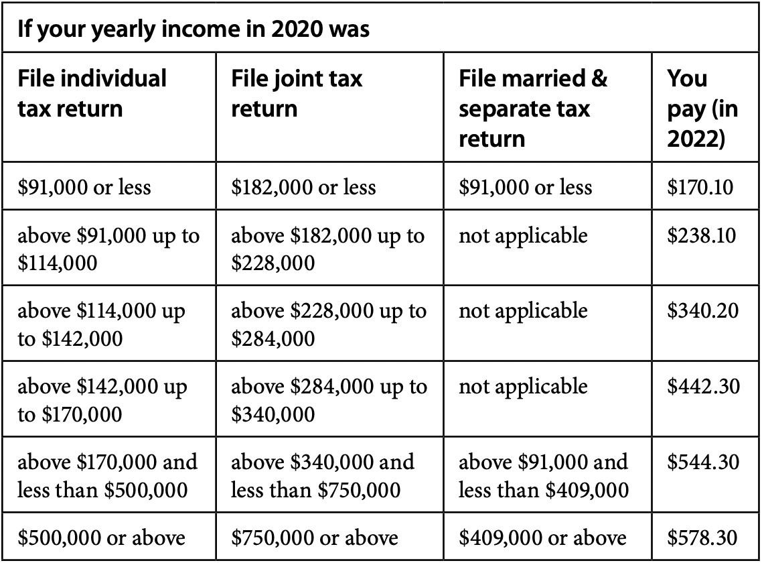

https://www.medicare.gov/Pubs/pdf/11579-medicare-costs.pdf

****

REFORMS SUGGESTED

Below are excerpts from an analysis conducted a decade ago on this subject by the Empire Center for Public Policy. Our center concurs with the four suggested policy reforms discussed below.
https://www.empirecenter.org/publications/nearly-360-billion-in-debt/

https://www.empirecenter.org/publications/iceberg-ahead/
Because these liabilities are now beginning to count against government balance sheets, OPEB poses a more direct threat to their solvency than rising pension costs. The economic decline of upstate cities such as Buffalo will only accelerate if they continue to pile a growing OPEB burden onto their shrinking tax bases. Even in more affluent suburban areas, the rising cost of health insurance for retirees and their dependents threatens to consume more and more scarce resources needed to fund basic services.

The good news for New York taxpayers is that public-sector retiree health benefits, unlike pensions, are not guaranteed by the state Constitution. Elected officials can still change course on retiree health care by restructuring benefits for both current retirees and active employees.

Pensions are based on length of service, with the biggest benefits flowing to those who have worked the longest. However, as explained below, most of New York’s state and local governments offer the same full employee health coverage to all vested retirees, regardless of years of service. Early retirees, who have not reached the Medicare eligibility age of 65, comprise a disproportionately large share of public-sector retiree health costs.

The leading source of retiree benefits for government workers in New York is the New York State Health Insurance Program (NYSHIP), administered by the state Department of Civil Service. NYSHIP consists of a broad indemnity program known as the Empire Plan, plus an array of managed-care options offered by HMOs on a regional basis. NYSHIP, the sole source of health insurance for state employees, is also open to local governments and public authorities.

NYSHIP provides benefits to over 1.2 million state and local government retirees and their dependents.

When NYSHIP was first created in 1957, the employer share of the premium was 50 percent for individual coverage and 35 percent for additional dependent coverage. The employer share grew over time; for employees hired prior to 1983, the state pays 100 percent of the premium for individual coverage. From 1983 to 2011, the employer share has been set at 90 percent for individual coverage and 75 percent of additional dependent coverage. Under contracts negotiated by the state government’s largest unions in 2011, those percentages were decreased to a range of 84 to 88 percent and 69 to 73 percent, respectively, with higher-salaried workers paying the biggest increases in premiums. The minimum employer contribution for local agencies participating in NYSHIP is still set at the original levels of 35 to 50 percent, but can go as high as 100 percent.

To remain eligible as a retiree for continuing subsidized health insurance on the same basis as an active employee, a state worker must have spent at least 10 years on the state payroll and must have reached the minimum retirement age, which is 55 for the vast majority of current employees other than police and corrections officers. (The minimum retirement age is 62 for non-police and fire employees hired between Jan. 1, 2010 and March 31, 2012, 63 for workers hired after April 1, 2012.)

The city government is even more generous than the state–covering 100 percent of both individual and family premiums for basic coverage.

Eligibility guidelines for the city plans are similar to those on the state level: employees qualify for continuing health coverage if they are eligible for a pension and retire after at least 10 years on the city payroll (or 15 years in the case of newly hired teachers starting in 2009.) Employees hired before Dec. 28, 2001, can qualify for a lifetime of free health benefits after just five years of working more than 20 hours a week for the city.

Under both the New York State and New York City employee insurance plans, Medicare is treated as “primary” insurance for all retired employees aged 65 or older; in other words, the state and city will pay for no cost that is already covered by Medicare.

With Medicare in place as the primary payer for most over-65 government retirees in New York, why does health coverage for retired workers cost so much? The answers:

Since Medicare Parts A and B include substantial co-pays and deductibles for hospital and physician care, along with limits on hospital and nursing home stays, those two parts of the program leave uncovered a substantial share of health care costs of the elderly. The New York State and New York City employee health insurance plans make up the difference, providing what amounts to supplemental “Medigap” coverage for their retired members.
While Medicare Part A is financed through a payroll tax, roughly 25 percent of Medicare Part B costs are financed by premiums charged to beneficiaries. Both New York State and New York City, as well as many local employers, also cover the entire Part B premium for their retired workers. As of 2012, the premium was set at $99.90 a month. (That figure is in 2022.)

Most state and local government workers retire years before they are eligible for Medicare. As noted, members of the state and city pension systems can retire as young as 55. Police officers and firefighters can retire when still in their 40s after as few as 20 years of work. For this reason, retiree health care costs tend to be highest for cities and counties, which employ the highest concentration of public safety officers. Early retirees were barely one-third of all retirees in NYSHIP’S statewide Empire Plan but accounted for more than half of the Empire Plan’s gross claims in 2005.[7]

The Legal Status of OPEB

Article V, Section 7 of New York’s state constitution treats pension income as a contractual entitlement that cannot be “diminished or impaired.” However, the state’s highest court has ruled that this provision does not apply to retiree health insurance.[8] The legal status of retiree health benefits varies by employer, as determined in a series of other state court decisions over the past 30 years. This much is clear:

1. Under the state Taylor Law, employee health insurance is a mandatory subject of collective bargaining between government employers and public employee unions.[9]

2. Unions do not represent retired employees, but unions can bargain with government employers over the benefits that active employees will receive after they retire.

3. In cases where retiree health benefits have been stipulated in a union contract, they can only be changed through collective bargaining.

4. If retiree health benefits are not stipulated in a union contract, they can be restructured, reduced or eliminated by an employer unilaterally, without collective bargaining.

Benefit levels for retired state workers, including premium shares and reimbursement for Medicare Part B premiums, are determined by a combination of state law, NYSHIP plan design, and other regulations. This means the governor and the Legislature retain considerable leeway to unilaterally reduce the state’s massive OPEB liability by restructuring benefits for retirees. In fact, both Governor David Paterson and Governor Andrew Cuomo have attempted do to just that (see “False Starts, Sidesteps and Baby Steps in Albany” on p. 20).

Public school retirees are an exception to this rule, however. Under a temporary law first enacted in 1994 and regularly extended thereafter, the governing boards of school districts outside New York City have been barred from making any change in retiree health benefits unless the same change is collectively bargained for active employees, regardless of whether those benefits were contractual to begin with. This restriction was made permanent as part of a pension “reform” law passed with Governor Paterson’s support in late 2009.

The bottom line

Given the constitutional prohibition on diminishment or impairment of pensions, changes in pension benefits, such as the newly enacted Tier 6 plan, have only applied to newly hired employees. As a result, these changes take many years to produce significant savings.

Unlike pensions, however, retiree health benefits for government employees can be restructured in ways that produce bigger savings sooner. This is especially true in situations where the benefits were established by local law or custom. Even in school districts and localities where retiree health benefits are contractually created, change is at least possible – if employers are sufficiently determined to make it an issue at the bargaining table.

Only 28 percent of firms with more than 200 employees, and 3 percent of smaller firms, offered health benefits to any retirees as of 2010.[10]

Even among larger firms offering such coverage, retired employees are asked to share more of the cost burden than their government counterparts. For example, only 8 percent of the largest employers replicate New York City’s practice of insuring early retires completely free of charge, according to a recent survey.

New York State covers an average of 91 percent of premiums for all retirees; in the private sector, by contrast, early retirees in large employer plans must pay an average of 51 percent of their medical costs.[11]

In some significant respects, state and local retiree health benefits in New York are more generous than those available to federal employees. For example, the federal government covers only 72 percent of the health insurance premium—and, notably, not Medicare Part B premiums—for its retired employees. On the other hand, federal employees can qualify for continuing health coverage if they retire after only five years, which is half the vesting period for New York State employees and city workers hired since 2001.

New York’s state and local retiree health benefit packages also are more generous in key areas than those offered in many other states. Only five states, other than New York, reimburse the Medicare Part B premium for all retired employees.[12]

As shown in Table 3 beginning on page 14, the unfunded retiree health care obligations reported by these 89 entities add up to more than $210 billion. Based on this sample, it can be estimated that OPEB obligations for all other public employers total nearly $39 billion, three-quarters of which could be attributed to school districts. That would bring the estimated unfunded OPEB liabilities for all levels of government in New York to nearly $250 billion.

(Comptroller Thomas) DiNapoli has sought to remedy this by pro­posing legislation that would allow locali­ties the option of creating their own trust funds in the comptroller’s custody.
The benefit that comes from putting money in a trust is that it starts to earn interest and, over time, that interest becomes another funding source for the benefits, replacing some of the contribution that would otherwise come from taxpayers,” the Pew study said.

A temporaryTask Force on Retiree Health Insurance created by Governor David Paterson in 2009 was presented with several options for reducing retiree health costs, including increases in retiree premiums, elimination or reduction of Part B premium reimbursements, creation of a sliding scale of benefits based on years of service, and establishment of a fixed-dollar contribution.[30]

1. Preserve health benefits for workers who have already retired, but stop reimbursing Medicare Part B premiums for those over 65, and require early retirees to pay a larger share of their own premiums.

2. Reserve the greatest benefit to those who have worked the longest, along the lines initially proposed by Governor Paterson in his 2009-10 budget.

3. Clarify existing law to allow trust funds to cover adjusted OPEB liabilities, but mandate that required contributions to the fund are based on returns from conservative, low-risk investment strategies.

4. Eliminate retiree health insurance coverage for all new hires and employees on the payroll for less than 10 years, and shift these workers into a “retirement medical trust.” Government workers would make tax-free contributions to accounts managed by their unions, which would pool and invest the money to cover medical expenses after they retire.

Adoption of this four-part strategy would immediately save the state more than $300 million a year, assuming early retirees were immediately required to pay one-third of premium costs now covered by state government (lowering the average employer share to 61 percent).[34] These changes also would significantly reduce the state’s unfunded OPEB liability.

Repeal the 2009 state law restricting the ability of school districts to alter retiree health benefits;

Require all active and retired public employees in New York to contribute at least 10 percent to individual coverage and 25 percent to family coverage premiums (the same level as state workers), as recommended in 2008 by the state Commission on Local Government Efficiency and Competitiveness;[35]

Amend the Taylor Law to flatly prohibit future collective bargaining of retiree health benefits in New York’s public sector.[36]

****

