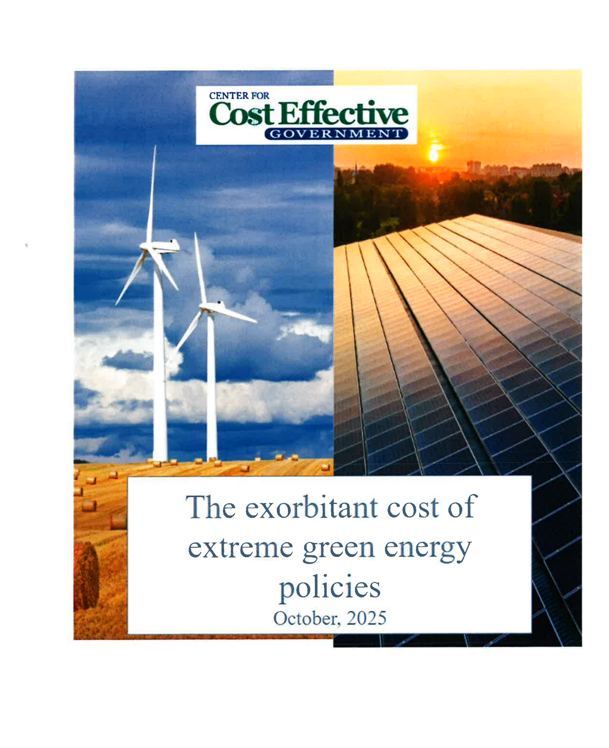

TABLE OF CONTENTS

INTRODUCTION 2

I: New York’s Rising Rates 10

II: New Jersey Facing a Rate Crisis as Well 12

III:The Need for More Power Due to AI 12

IV: Germany’s Failed Experiment 12

V: California’s Failed Experiment 13

VI: The High Cost of Offshore Wind Energy 13

CONCLUSION

Electricity Prices Soaring Due to Extreme Green Energy Policies

Throughout New York State, the nation, and many parts of the world, soaring energy costs are having a major deleterious impact on state and national economies, as well as individual energy consumers.

Since New York adopted a radical new green energy policy in 2019, consumers have seen their average monthly rates for residential electric bills explode approximately 50% between 2019 and 2025.

According to the New York Post Editorial Board, “…it’s only going to get worse. Con Edison is seeking hikes to electric and gas bills, and the state’s Public Service Commission approved steep National Grid rate increases in August, which will add an extra $600 per year to many upstaters’ utility bills.”

According to Zilvinas Silenas of The Empire Center for Public Policy:

For March 2025, the average price of electricity in New York was estimated at $0.25 per kWh for residential users and $0.095 per kWh for industrial users. These rates are significantly above the U.S. averages of $0.17 per kWh and $0.08 per kWh, respectively.

Households in New York pay 48 percent more, and industry pays 15 percent more for electricity than the national average, in large part due to the state’s aggressive green energy policies. (Emphasis added.)

Jordan McGillis and John Kechum, in an article for the New York Post, noted:

According to the latest federal data, New Yorkers statewide pay 24.4 cents per kilowatt-hour for power. City households are hit even harder, paying over 31 cents per kilowatt-hour. Meanwhile, Pennsylvanians pay just 17.6 cents.

The rising costs in New York can be seen with more detail in the chart below:

Source: NYSERDA Monthly Average Retail Price of Electricity - Residential
Prices are cents per Kilowatt-hour (¢/kWh)

 | 2025 | 2024 | 2023 | 2022 | 2021 | 2020 | 2019
January | 25.31 | 23.44 | 23.57 | 21.0 | 18.3 | 17.6 | 17.3
February | 26.20 | 24.23 | 23.60 | 21.6 | 18.8 | 17.4 | 17.6
March | 25.43 | 23.64 | 21.18 | 19.7 | 18.0 | 17.2 | 16.8
April | 25.67 | 22.97 | 19.81 | 21.1 | 18.5 | 17.3 | 17.5
May |  | 23.60 | 20.47 | 21.9 | 19.9 | 18.5 | 17.3
June |  | 24.51 | 21.63 | 22.4 | 19.5 | 19.1 | 18.5
July |  | 25.01 | 22.27 | 21.9 | 19.6 | 18.7 | 18.6
August |  | 25.21 | 22.33 | 21.2 | 19.9 | 18.4 | 18.4
September |  | 24.98 | 23.23 | 24.0 | 20.5 | 19.0 | 18.7
October |  | 24.98 | 22.70 | 23.3 | 20.6 | 19.3 | 18.6
November |  | 24.69 | 22.72 | 23.7 | 20.0 | 19.0 | 18.0
December |  | 24.37 | 22.52 | 22.8 | 19.5 | 18.3 | 17.3

The high cost in New York and New Jersey as of October 2025 can be compared to the cost in other states around the nation in the chart below:

State ▲ | Residential (¢/kWh) | Commercial (¢/kWh) | Calculated Average (Res. & Com.)
Alabama | 16.00 | 14.44 | 15.22¢ per kWh
Alaska | 26.88 | 22.93 | 24.91¢ per kWh
Arizona | 15.28 | 12.98 | 14.13¢ per kWh
Arkansas | 13.33 | 10.84 | 12.09¢ per kWh
California | 33.52 | 26.69 | 30.11¢ per kWh
Colorado | 16.16 | 13.51 | 14.84¢ per kWh
Connecticut | 27.24 | 21.36 | 24.30¢ per kWh
Delaware | 18.15 | 12.45 | 15.30¢ per kWh
District of Columbia | 22.70 | 20.37 | 21.54¢ per kWh
Florida | 15.36 | 11.48 | 13.42¢ per kWh
Georgia | 16.00 | 12.37 | 14.19¢ per kWh
Hawaii | 40.96 | 35.54 | 38.25¢ per kWh
Idaho | 12.07 | 9.00 | 10.54¢ per kWh
Illinois | 18.33 | 12.86 | 15.60¢ per kWh
Indiana | 16.60 | 13.71 | 15.16¢ per kWh
Iowa | 15.39 | 12.64 | 14.02¢ per kWh
Kansas | 15.00 | 12.07 | 13.54¢ per kWh
Kentucky | 13.62 | 11.88 | 12.75¢ per kWh
Louisiana | 12.64 | 11.15 | 11.90¢ per kWh
Maine | 28.14 | 21.05 | 24.60¢ per kWh
Maryland | 19.33 | 14.82 | 17.08¢ per kWh
Massachusetts | 30.37 | 23.10 | 26.74¢ per kWh
Michigan | 20.85 | 14.87 | 17.86¢ per kWh
Minnesota | 17.14 | 13.63 | 15.39¢ per kWh
Mississippi | 13.94 | 12.85 | 13.40¢ per kWh
Missouri | 15.84 | 12.42 | 14.13¢ per kWh
Montana | 14.85 | 13.14 | 14.00¢ per kWh
Nebraska | 13.17 | 9.35 | 11.26¢ per kWh
Nevada | 11.42 | 8.80 | 10.11¢ per kWh
New Hampshire | 23.51 | 19.46 | 21.49¢ per kWh
New Jersey | 24.88 | 18.00 | 21.44¢ per kWh
New Mexico | 14.77 | 11.46 | 13.12¢ per kWh
New York | 26.53 | 21.72 | 24.13¢ per kWh
North Carolina | 13.33 | 9.76 | 11.55¢ per kWh
North Dakota | 13.68 | 8.05 | 10.87¢ per kWh
Ohio | 17.52 | 11.35 | 14.44¢ per kWh
Oklahoma | 13.62 | 9.77 | 11.70¢ per kWh
Oregon | 15.77 | 11.60 | 13.69¢ per kWh
Pennsylvania | 19.70 | 12.37 | 16.04¢ per kWh
Rhode Island | 26.84 | 22.15 | 24.50¢ per kWh
South Carolina | 14.71 | 11.00 | 12.86¢ per kWh
South Dakota | 14.23 | 11.27 | 12.75¢ per kWh
Tennessee | 13.98 | 13.49 | 13.74¢ per kWh
Texas | 15.23 | 8.60 | 11.92¢ per kWh
Utah | 13.12 | 10.58 | 11.85¢ per kWh
Vermont | 23.21 | 19.79 | 21.50¢ per kWh
Virginia | 15.41 | 9.66 | 12.54¢ per kWh
Washington | 12.98 | 11.30 | 12.14¢ per kWh
West Virginia | 15.82 | 11.49 | 13.66¢ per kWh
Wisconsin | 18.57 | 13.36 | 15.97¢ per kWh
Wyoming | 14.89 | 9.78 | 12.34¢ per kWh
U.S. Average | 17.47 | 12.96 | 15.22¢ per kW

In 2019, the New York State Legislature enacted a sweeping law, the Climate Leadership and Community Protection Act (CLCPA), which imposed mandates seeking a 40% reduction in greenhouse gas emissions (GHG) by 2030, and zero greenhouse gas emissions (GHG) by 2050. It also calls for the state to have 100% renewable electricity usage by 2040.

But recently, New York State government has been quietly telling the utilities to slow walk the decommissioning of the gas fire power plants. They don’t want their green extreme friends to hear about it, but our state leaders are finally conceding that their mandate that calls for 100% of New York power to be from renewable energy was ridiculously unrealistic.

Many warned years ago, dating back to that impractical law, that this was all showboating by then-Governor Cuomo and others trying to curry favor with the environmental leftists as they were seeking higher office.

It was never realistic that we would be able to get off of oil and gas within that time.

What the state did was dramatically increase our electric rates and shift boatloads of money to their special interest allies in the alternative energy industries. Ironically, New York’s carbon footprint was worse after the passage of this bill, but our electric rates are far higher.

Now the officials have to worry about blackouts, so they have to face reality and make sure that our march toward renewables is gradual and more realistic.

The law had a goal of reducing greenhouse gas emissions by 40% from 1990 levels by 2030. However, there is much to be done to meet this goal. The NYS Part 496 1990 has baseline emissions of 404.26 mmt CO₂e. In 2020, the total emissions in New York State were 344.85 CO₂e, representing a 15% reduction from the 1990 emissions levels. To reach the 2030 limit of 245.9 CO₂e, an additional 29% reduction would be required.

Interestingly, greenhouse emissions in the US have actually dropped since 2005 by 14% bucking the trend worldwide, where it was actually increasing by over 20% This was primarily the result of switching from dirtier coal and oil to a cleaner fossil fuel, natural gas.

*****

New York’s Rising Rates

Here in New York, it is undeniable that state ratepayers are shouldering some of the nation’s steepest power costs: as of May, the average monthly residential bill was up 13% over the previous year and 54% since May 2019, with energy prices roughly 33% above the national average.

Residential customers paid more than 24¢ per kWh—about 50% higher than the U.S. average.

The average monthly ConEd bill is now $154 higher than five years ago despite U.S. wind and solar capacity nearly tripling since 2017, and ConEd is seeking another increase—11% for electricity and 13% for gas—to keep pace with the state’s green-energy targets.

Citing a 2023 FERC study warning that New York’s grid is at risk, some editorialists are contending that state policies have turned utilities into “energy bagmen” and urges Albany to rethink all-electric mandates and curb what it regards as wasteful green-energy subsidies.

Decades ago, electricity bills were based on usage, supply cost, and the utility company’s charge for delivering that electricity. The Public Service Commission (PSC) uses a formula to determine the amount of profit the utility will be allowed to keep. In 1996, the PSC directed utility companies to add a “system benefits charge” to electricity bills.

Despite it costing less than $3 per month for a typical home in New York City, it opened the door for utility companies to collect additional funds outside of their approved rates, to help subsidize state renewable-energy projects.

New York State then joined the Regional Greenhouse Gas Initiative (RGGI), a cap-and-trade program that required power plants to buy allowances for their carbon dioxide emissions. Proceeds from the RGGI go into a separate public authority controlled by gubernatorial appointees instead of the state’s general fund. In 2024, the RGGI’s proceeds were $236 million.

In New York, the average customer spent more than $200 per month on electricity,
That number will increase further as the New York State Electric and Gas Company said it would charge 23.7% more in 2026.

Additionally, New York State’s Public Service Commission approved National Grid rate increases that may potentially raise utility bills in upstate New York by $600 a year. Moreover, Con Edison continues to request additional rate hikes, including one that would increase average gas and energy bills to a level costing $154 higher than what was charged in 2020 ($500 as compared to $346).

Whereas in 2020, the average Con Edison customer paid $346 monthly ( $176.36 for gas at 100 therms per month and $170 for electricity) at 600 kilowatt-hours per month, in 2025, customers could be paying $500 per month, with $289 going to gas and $211 going to electricity.

Furthermore, New Yorkers may be further strained by having to pay 2.5 times the market rate for electricity that is generated by the Empire Wind One wind farm. This sudden jump, over double current rates, will make it even harder for New Yorkers to afford electricity.

New York’s Climate Change Superfund Act has also received much pushback, with the Justice Department seeking to have it declared unconstitutional. The law intends to collect $75 billion from the biggest polluters, such as oil companies, over 25 years. Some lawmakers believe that oil companies should pay $3 billion each year for the next 25 years as a payback for having used fossil fuels as their mode of generating electricity.

Detractors not only question the legal validity of the measure but also express concern that it will only further burden small businesses and ordinary people who would be the ones footing the hefty bill after costs are passed along to them. The companies that would end up having to pay these damages would eventually raise their prices, effectively passing them on to consumers. The law would needlessly punish businesses and consumers under the guise of saving taxpayers money.

New Jersey Facing a Rate Crisis as Well

The average residential customer in New Jersey saw an increase of approximately 17 to 20% in 2025. One resident of Clark, New Jersey, claimed her electricity bill rose from $174 in June to over $300 in July. This is despite New Jersey’s Public Service Electric & Gas having told Marinez to expect an increase of 17% instead.

The rate hikes are mainly due to both energy supply and demand. Energy supply has decreased, in large part due to the policy decisions that inactivated various power plants, while demand has increased significantly. Load growth has increased from about 1% to 3% per year, with peak demand projected to reach 154 GW this year, the highest they've ever expected.

The Need for More Power Due to AI

Much of this demand is attributed to the rapidly increasing needs of data centers, which account for 4% of PJM’s load, with projections for them to take 12% of the load by 2030.

Another contributing factor to surging electricity costs across New York and New Jersey is artificial intelligence (AI). Large companies such as Amazon, Google, Meta, and Microsoft, which are at the forefront of AI innovation, place immense strain on the grid to power their demanding AI projects. AI data centers are becoming large energy users, even outpacing electric vehicles in their power demand growth. However, as noted by Abe Silverman from the Ralph O’Connor Sustaining Energy Institute at Johns Hopkins University, building new plants takes “five to ten years, and billions of dollars of investment.”

Germany’s Failed Experiment

Overly ambitious policy initiatives to shut down traditional power generation to be replaced by less reliable wind and solar energy has resulted in significant negative consequences throughout the globe.

These excessive requirements to help increase sustainability have backfired in many instances. In Germany, for instance, an optimistic energy transition plan involved shutting down nuclear power plants. In 2011, Germany’s 17 nuclear reactors generated over 33% of the country’s electricity. The shutdown of these nuclear plants led to a return to using fossil fuels. Consequently, greenhouse gas emissions and reliance on foreign energy sources actually increased.

Furthermore, according to PwC, Germany could have had 94% emission-free power generation in 2024 if it had maintained its nuclear reactor fleet. Instead, there is only 61% emission-free power generation, signifying a significant downfall.

According to the article, “Germany's Energy Crisis: Europe's Leading Economy is Falling Behind,” Germany is now considered by many to be “the sick man of Europe” as it once again sinks into an energy-related stagnation.

On a world scale, the crisis in Germany becomes clear, with Germany's electricity being twice as expensive as the cost in the United States.

California’s Failed Experiment

The state of California promulgates the most aggressive green policies in the nation. It has resulted in electric costs being approximately 50% above the national average and gasoline costs being 47 % above the national average.

Among the many mandates imposed by the California legislature upon the energy consumer are the following:

- The highest tax on gasoline in the nation at $.70 per gallon.
- New low carbon and fuel standards that will increase prices in addition six to fifteen cents per gallon.
- A 2035 mandate that 100% of all vehicles sold in California be electric.
- An additional estimated $.30 to $.70 per gallon to gasoline due to special gasoline formulation called CARBOB.

The High Cost of Offshore Wind Energy

Wind energy has an astronomical upfront cost.

According to NY Energy Ratings, “Developers are looking for a way to pay for the mounting costs of new wind energy projects. They have even asked the PSC to increase New York electric rates.” This is estimated to result in an increase of about 4%, or $4.67 per month for ratepayers. Some projects are costing double what they were expected to.

At first, many proponents of offshore wind were touting that it was going to be saving ratepayers money. As these proclamations have been proven inaccurate, many lawmakers have shifted their talking points to now claim that it is an expense well worth it. The common green mantra was: “We need to move into clean power. It's going to cost you an arm and a leg, but if you’re a good person, you’ll do it

CONCLUSION

The decision as to whether the cost of a policy initiative is worth it is to be determined by the people in a democracy. As a baseline, however, the people must at least be informed of the truth so they can come to an intelligent conclusion. At the very least, they should be aware of the following:

- Offshore wind costs more, not less, for the ratepayer.

- Shutting down existing nuclear and gas powered plants makes the grid more vulnerable to brown outs.

- Ending the gradual transition to natural gas actually leads to a higher carbon footprint, not a lower one.

- The hundred percent renewable energy plans in place in many states will simply not be achieved.

- Enacting extreme green policies that dramatically increase energy consumption costs can cripple economies as we’ve seen in Germany. They also have the potential to have hundreds of millions of people regress back into deprivation after having escaped poverty as a result of the industrialization in Asia over the last several decades.

- There is a way to achieve a clean planet without having a devastating impact on the economic well-being of billions of people. The transition to clean fuels must be realistic and gradual.

- Natural gas, which is much cleaner than coal or oil and is quite plentiful and can be combined with a clean nuclear energy to bridge the gap from the use of dirty coal and oil to a day where the majority of our energy will be generated through renewable, sustainable, cleaner products.

